**E-Learning Portal**

# A PROJECT REPORT

*In partial fulfilment of the requirements for the award of the degree*

## B.TECH

## IN

**COMPUTER SCIENCE AND ENGINEERING**

*Under the guidance of*

**GURUDEV ADHIKARY**

**And Technical Guidance by**

**Rahul Sharma**

BY

AVRADEEP NAYAK



**Vellore Institute of Technology,**

**Bhopal**

**In association with**



**(ISO9001:2015)**

***(Note: All entries of the proforma of approval should be filled up with appropriate and complete information. Incomplete proforma of approval in any respect will be summarily rejected.)***

|  |  |  |  |
| --- | --- | --- | --- |
| 1. | Title of the Project: | | **E-Learning Portal** |
| 2. | Project Made by: | | **AVRADEEP NAYAK** |
| 3.  4. | Name of the guide:  Name of the Technical Guide: | | **Mr. GURUDEV ADHIKARY**  Mr. Rahul Sharma |
|  |  |  | | |
|  |  |  | | |

***Project Version Control History***

|  |  |  |  |
| --- | --- | --- | --- |
| **Version** | **Member** | **Description of Version** | **Date Completed** |
| Final | AVRADEEP NAYAK | Project Report | 30/04/2023 |

Signature of Team Member Signature of Approver

Date: Date:

For Office Use Only

**MR. GURUDEV ADHIKARY**

**Approved**

Project Proposal Evaluator

**Not Approved**

**DECLARATION**

We hereby declare that the project work being presented in the project proposal entitled **“E-Learning Portal”** in partial fulfilment of the requirements for the award of the degree of **B.TECH** At **EDUSKILLERA, INDIA,** is an authentic work carried out under the guidance of **MR. GURUDEV ADHIKARY** and technical guidance by **MR. Rahul Sharma**. The matter embodied in this project work has not been submitted elsewhere for the award of any degree of our knowledge and belief.

Date:

Name of the Student : AVRADEEP NAYAK

***Signature of the students:***



#### EDUSKILLERA (An ISO 9001:2015 Certified)

# CERTIFICATE

This is to certify that this proposal of the minor project entitled **“E-Learning Portal**” is a record of bonafide work, carried out by **AVRADEEP NAYAK** under my guidance at **EDUSKILLERA**. In my opinion, the report in its present form is in partial fulfilment of the requirements for the award of the degree of **B.TECH** and as per regulations of the **EDUSKILLERA*.*** To the best of my knowledge, the results embodied in this report, are original in nature and worthy of incorporation in the present version of the report.

# Guide / Supervisor

------------------------------------------------

## MR. GURUDEV ADHIKARY

### Project Engineer

**EDUSKILLERA** (An ISO 9001:2015 Certified)

# ACKNOWLEDGEMENT

Success of any project depends largely on the encouragement and guidelines of many others. I take this sincere opportunity to express my gratitude to the people who have been instrumental in the successful completion of this project work.

I would like to show our greatest appreciation to **MR. GURUDEV ADHIKARY**, Project Engineer at **EDUSKILLERA**, India. I always feel motivated and encouraged every time by his valuable advice and constant inspiration; without his encouragement and guidance this project would not have materialized.

Words are inadequate in offering our thanks to the other trainees, project assistants and other members at **EDUSKILLERA** for their encouragement and cooperation in carrying out this project work. The guidance and support received from all the members and who are contributing to this project, was vital for the success of this project.

**CONTENTS**

* Overview
* History of Java And Java Servlets.
* Environment setup
* Modules
* Packages
* Web pages Java
* Security Mechanism
* Limitations
* Scope
* E-learning Platform using java

**OVERVIEW**

**Java full-stack** is basically a term used for a web developer that uses **Java** to develop the entire technology stack is referred to as **Java full stack developer**.

Java Servelets:

The clients send the request to the webserver.

The web server receives the request.

The web server passes the request to the corresponding servlet.

The servlet processes the request and generates the response in the form of output.

The servlet sends the response back to the webserver.

The web server sends the response back to the client and the client browser displays it on the screen.

There are four types of JDBC drivers:

1. **JDBC-ODBC Bridge Driver**
2. **Native Driver**
3. **Network Protocol Driver**
4. **Thin Driver**

**History of Java and Java Servlets**

Java

The history of Java is very interesting. Java was originally designed for interactive television, but it was too advanced technology for the digital cable television industry at the time. The history of Java starts with the Green Team. Java team members (also known as Green Team), initiated this project to develop a language for digital devices such as set-top boxes, televisions, etc. However, it was best suited for internet programming. Later, Java technology was incorporated by Netscape.

The team gathered to choose a new name. The suggested words were "dynamic", "revolutionary", "Silk", "jolt", "DNA", etc. They wanted something that reflected the essence of the technology: revolutionary, dynamic, lively, cool, unique, and easy to spell, and fun to say.

According to James Gosling, "Java was one of the top choices along with **Silk**". Since Java was so unique, most of the team members preferred Java than other names.

Java is an island in Indonesia where the first coffee was produced (called Java coffee). It is a kind of espresso bean. Java name was chosen by James Gosling while having a cup of coffee nearby his office.

Java Servelet

We define a Java Servlet or Jakarta Servlet as the technology to design and deploy dynamic web pages using the [Java](https://www.simplilearn.com/tutorials/java-tutorial/what-is-java) Programming Language. It implements a typical servlet in the client-server architecture, and the Servlet lives on the server-side.

There are several varieties of interfaces and classes available in the Servlet API. Some of them are as follows:

* HTTP Servlet
* Generic Servlet
* Servlet Request
* Servlet Response

In the life cycle of a servlet, we have mainly three stages, which are mentioned below.

* init()
* service()
* destroy()

The Java Servlets carry over the features of Java Programming Language. The key features offered by the Java Servlets are as follows.

* Portable
* Efficient
* Scalable
* Robust

**Environment Setup**

* A chrome browser is required for the windows users, Safari for Mac users and firefox for linux users.
* Will work for both android and windows.
* Minimum win 10 required.
* Macintosh (Intel, PPC, 68K)

**Modules**

A module allows you to logically organize your Java code. Grouping related code into a module makes the code easier to understand and use. A module is a Java object with arbitrarily named attributes that you can bind and reference.

Here's an example of a simple module, support.java:

**package** com.howtodoinjava.demo;

**public** **class** support {

**public** **static** **void** sayHello() {

System.out.println("Hello from HelloWorldApp");

}

}

The import Statement

You can use any Java source file as a module by executing an import statement in some other Java source file. The import has the following syntax –

import java.[module].[subs module].

**Packages**

**Package in Java is a mechanism to encapsulate a group of classes, sub packages and interfaces. Packages are used for:**

**Preventing naming conflicts. For example there can be two classes with name Employee in two packages, college.staff.cse.Employee and college.staff.ee.Employee**

**Making searching/locating and usage of classes, interfaces, enumerations and annotations easier**

**Providing controlled access: protected and default have package level access control. A protected member is accessible by classes in the same package and its subclasses. A default member (without any access specifier) is accessible by classes in the same package only.**

**Packages can be considered as data encapsulation (or data-hiding).**

Example :

import java.util.*;

util is a subpackage created inside java package.

Accessing classes inside a package

Consider following two statements :

// import the Vector class from util package.

import java.util.vector;

// import all the classes from util package

import java.util.*;

First Statement is used to import Vector class from util package which is contained inside java.

Second statement imports all the classes from util package.

**Webpages in java**

These are the principles that you should keep in mind to be able to build a Web application using  Servlet + JSP  satisfying criteria: code is simple, easy to understand and easy to maintain.

The principles:

1. Never allow users to directly access to your JSP page.
2. JSP is only considered as the place to display interface.
3. Servlet acts as the controller of the application flows and  program logical processing.
4. Open the JDBC connection and transaction management in Filter.

The application needs to run on a WebServer,  such as **Tomcat Server**, you can refer to download and declaration instructions of **Server Tomcat**in **Eclipse**at:

* [Install Tomcat Server for Eclipse](https://o7planning.org/10209/install-tomcat-server-for-eclipse)

Right-click the **SimpleWebApp** select **Properties**.

You have to download JDBC library to driving the connection with the Database. In this document, I download both of 3  JDBC libraries for **Oracle, MySQL, SQL Server**, in practice, you only need JDBC library corresponding to the type of database you are using.

You can see download instruction of JDBC driver at:

* [JDBC Driver Libraries for different types of database in Java](https://o7planning.org/10227/jdbc-driver-libraries-for-different-types-of-database-in-java)

**Security Mechanism**

* Personal data will be kept safe from outside.
* Nobody can steal your data.
* One can submit there assignments personally. i.e. No one will have access to one’s assignments.
* Security guarantee to all the users and teachers.

**Limitations**

* Time limit not given for assignment submission.
* Teacher should be giving the time limit personally to every student.
* Courses will be updated lately.

**Scope**

* One student can learn new concepts and will get weekly assignments after learning every module.
* All students will get the best opportunity to learn from industry experts.
* Teachers can also showcase there ability to teach the students by giving their 100%.

**E-Learning Platform**

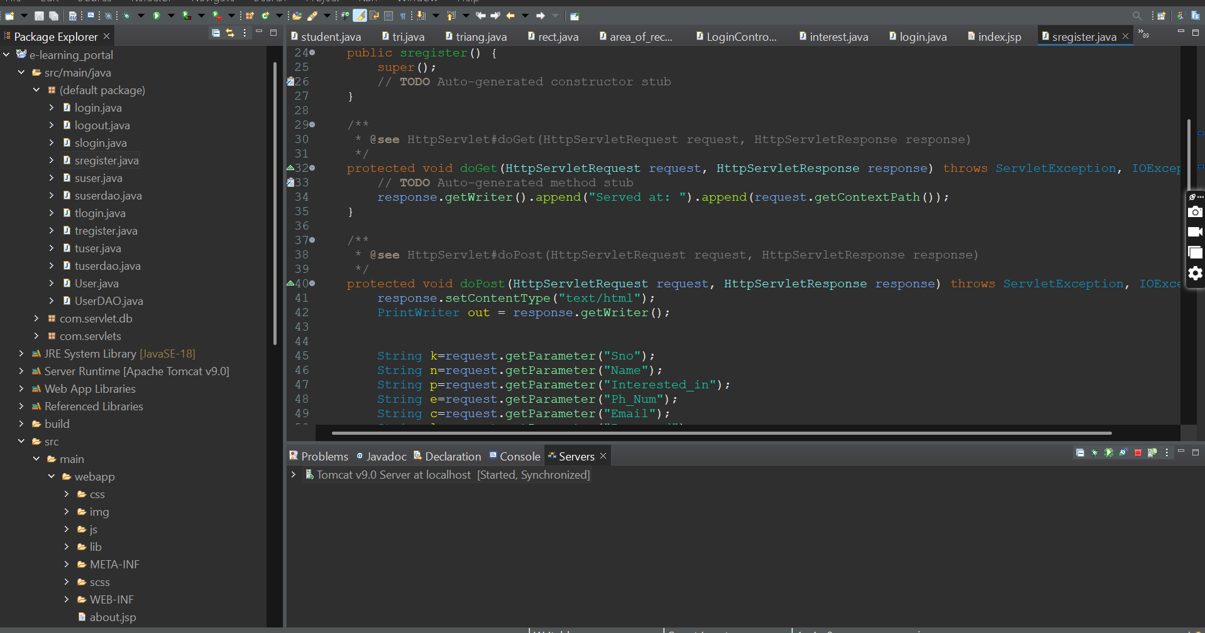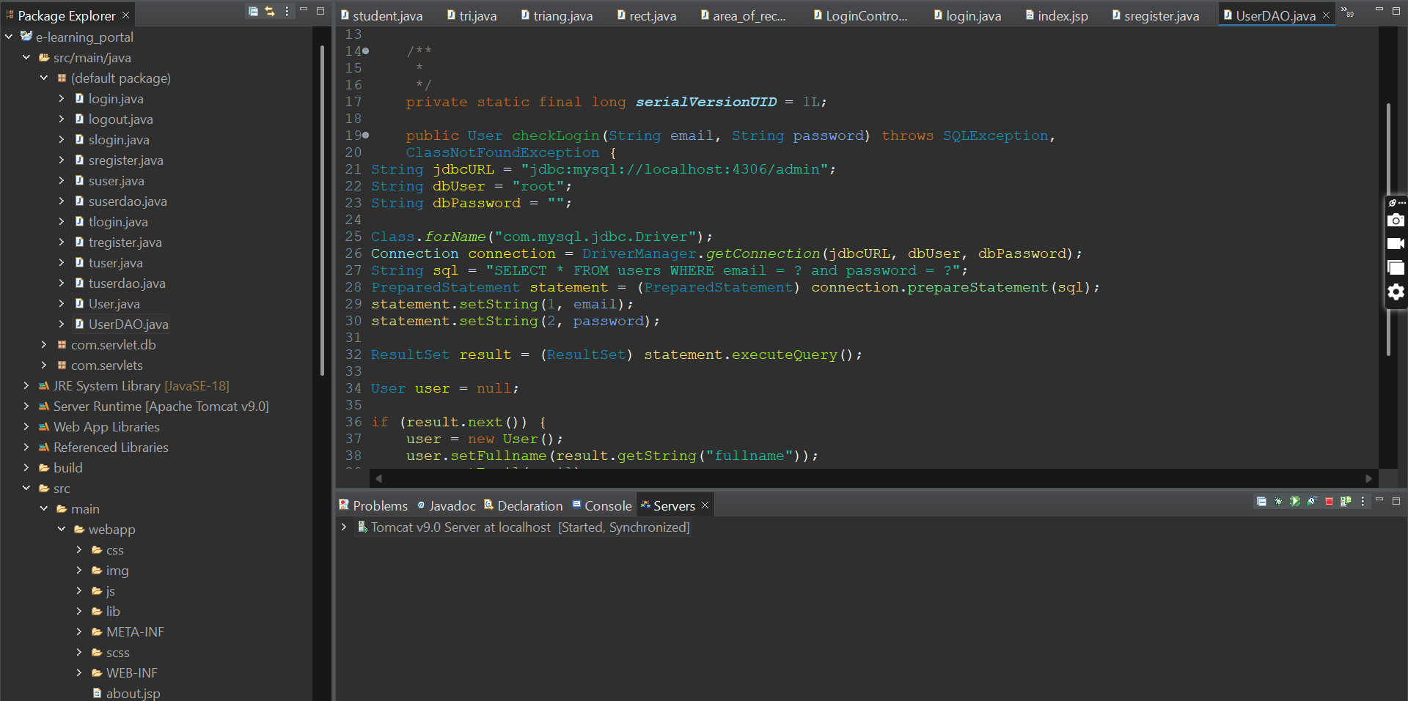

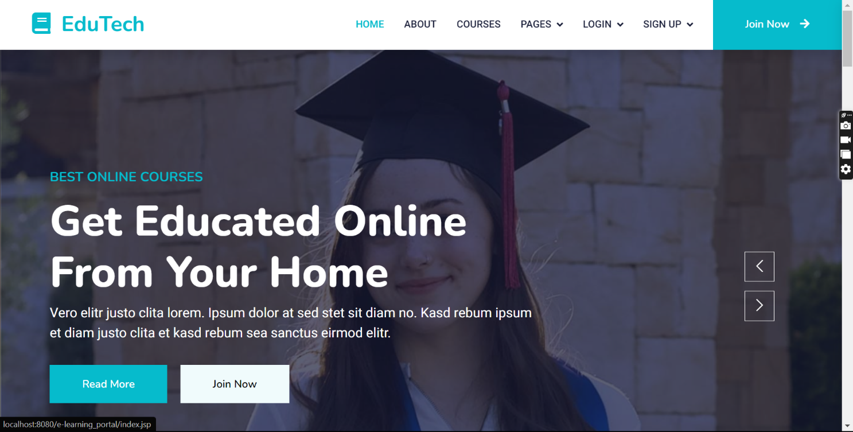

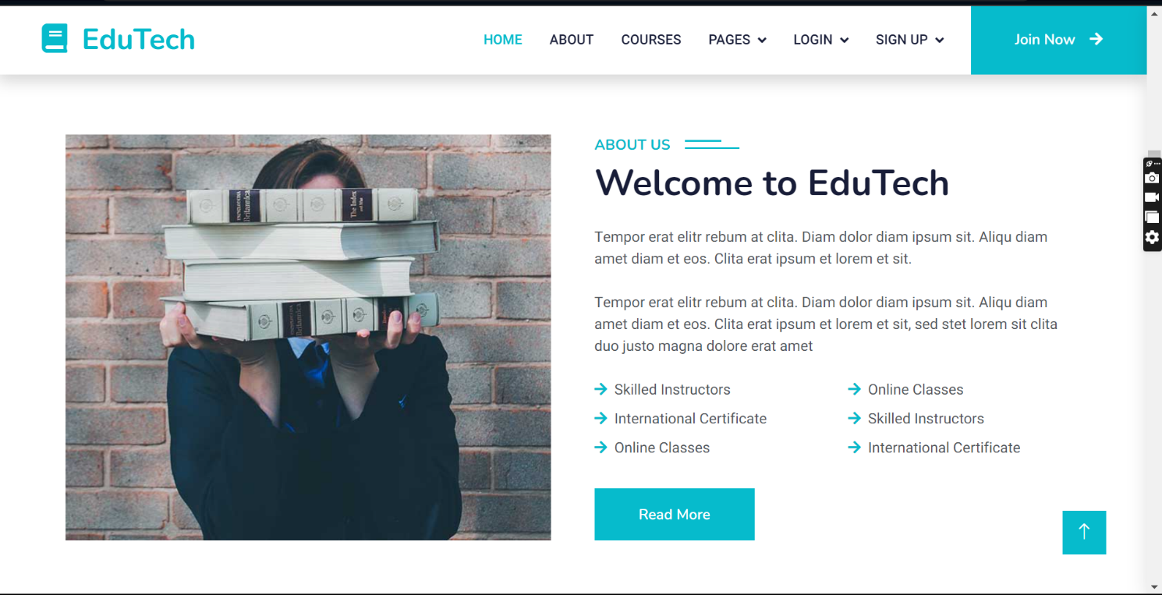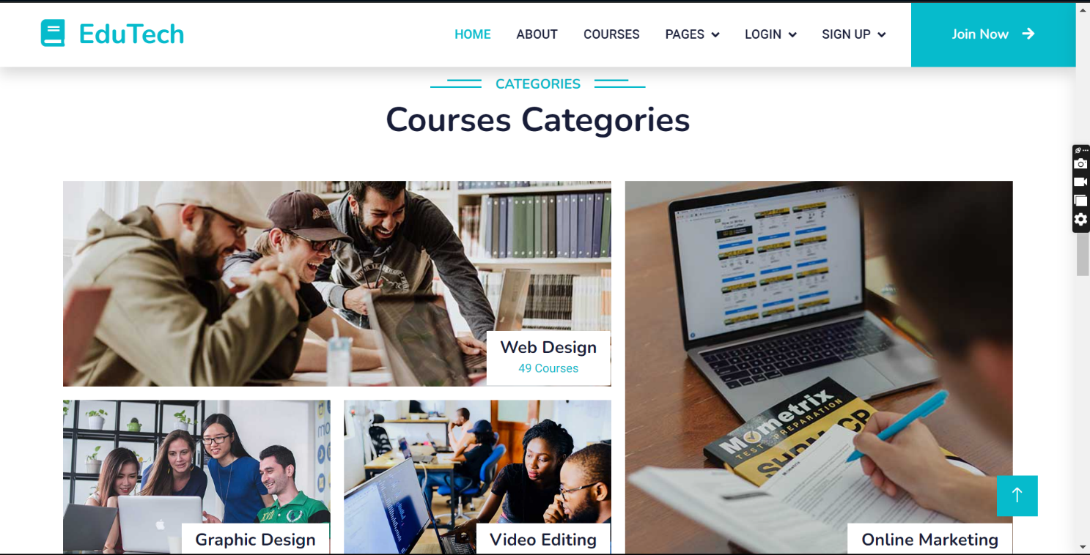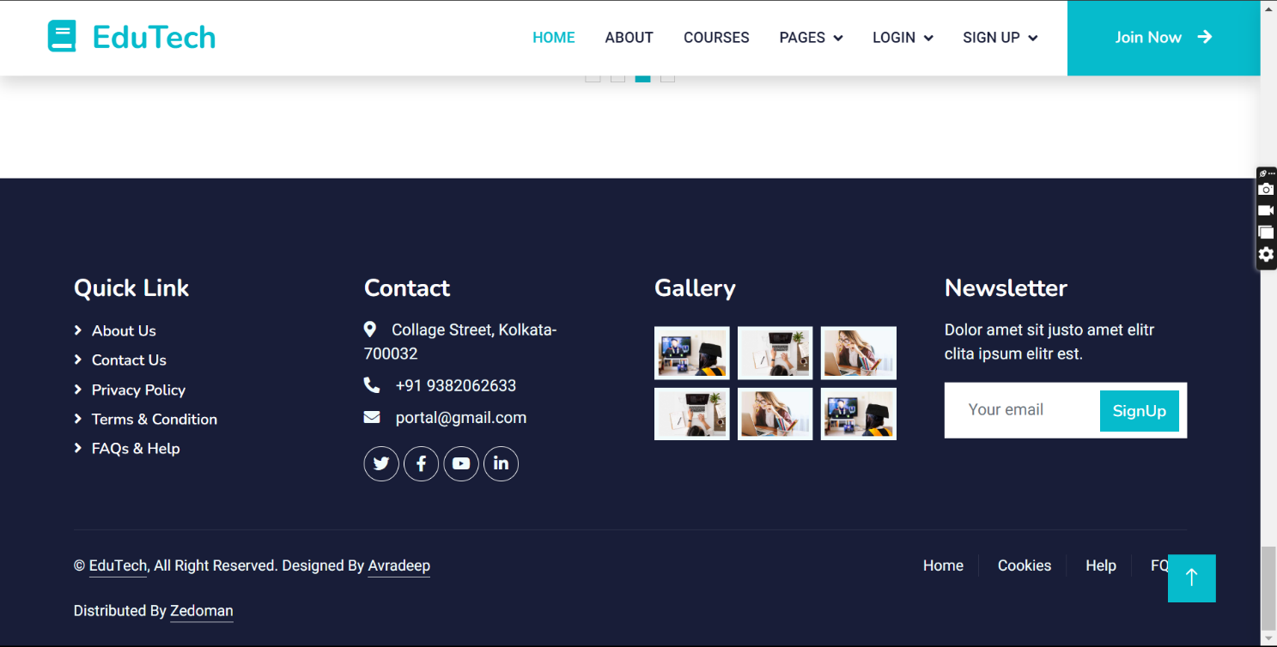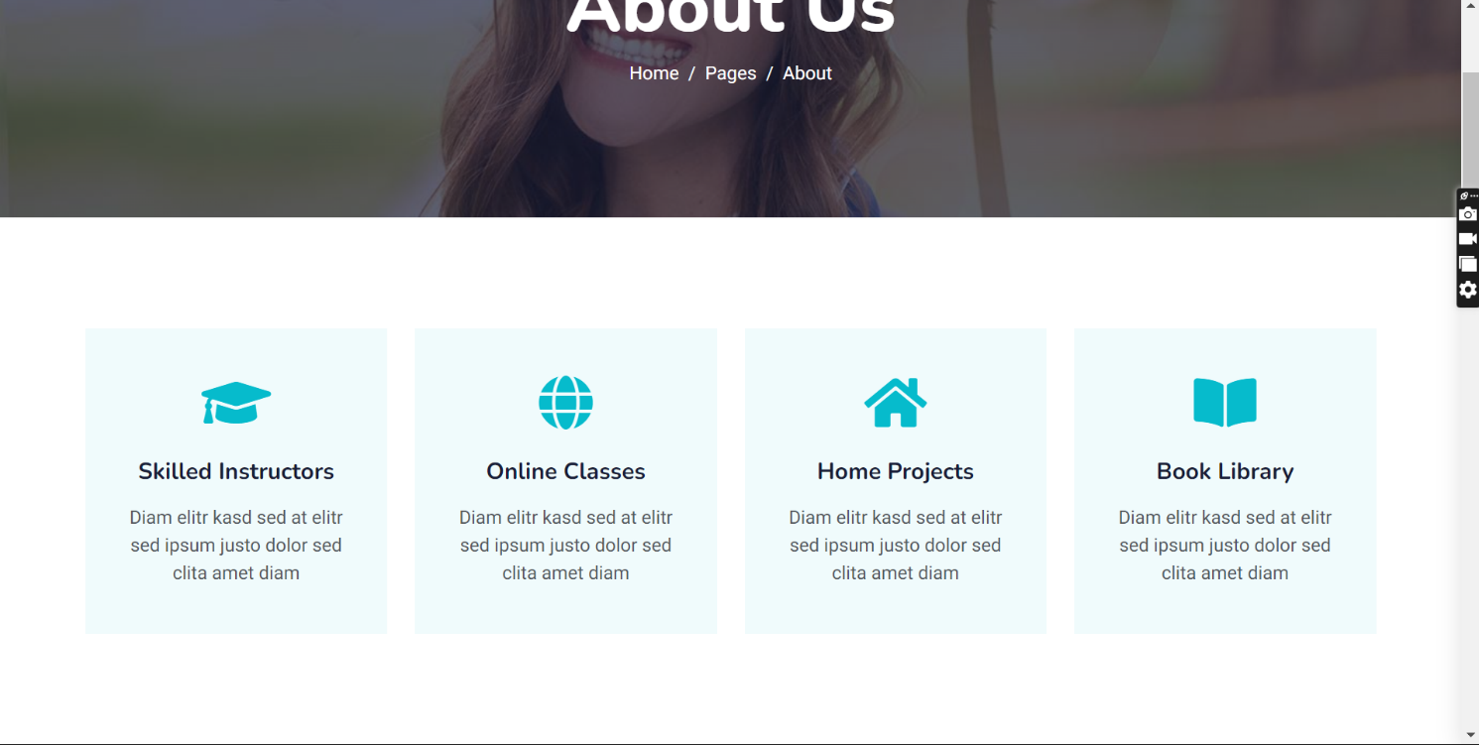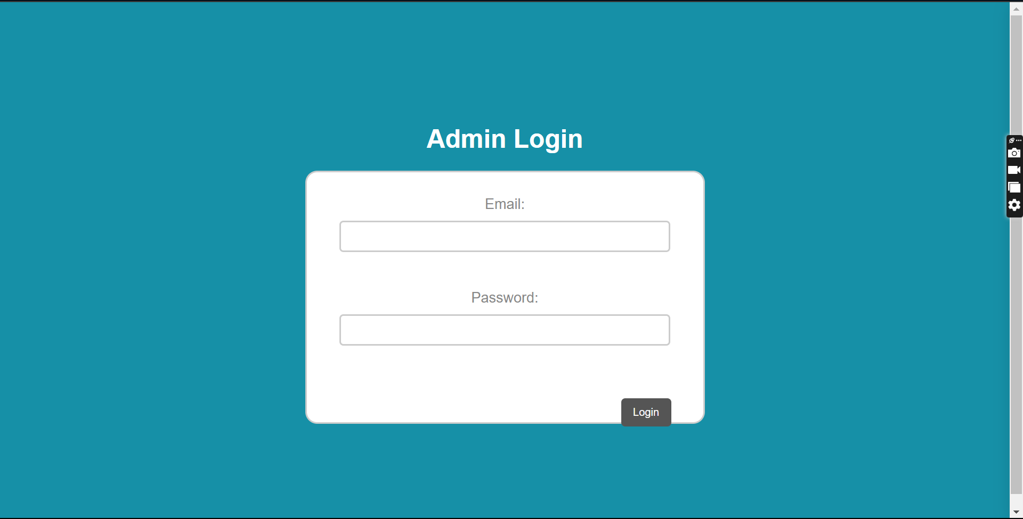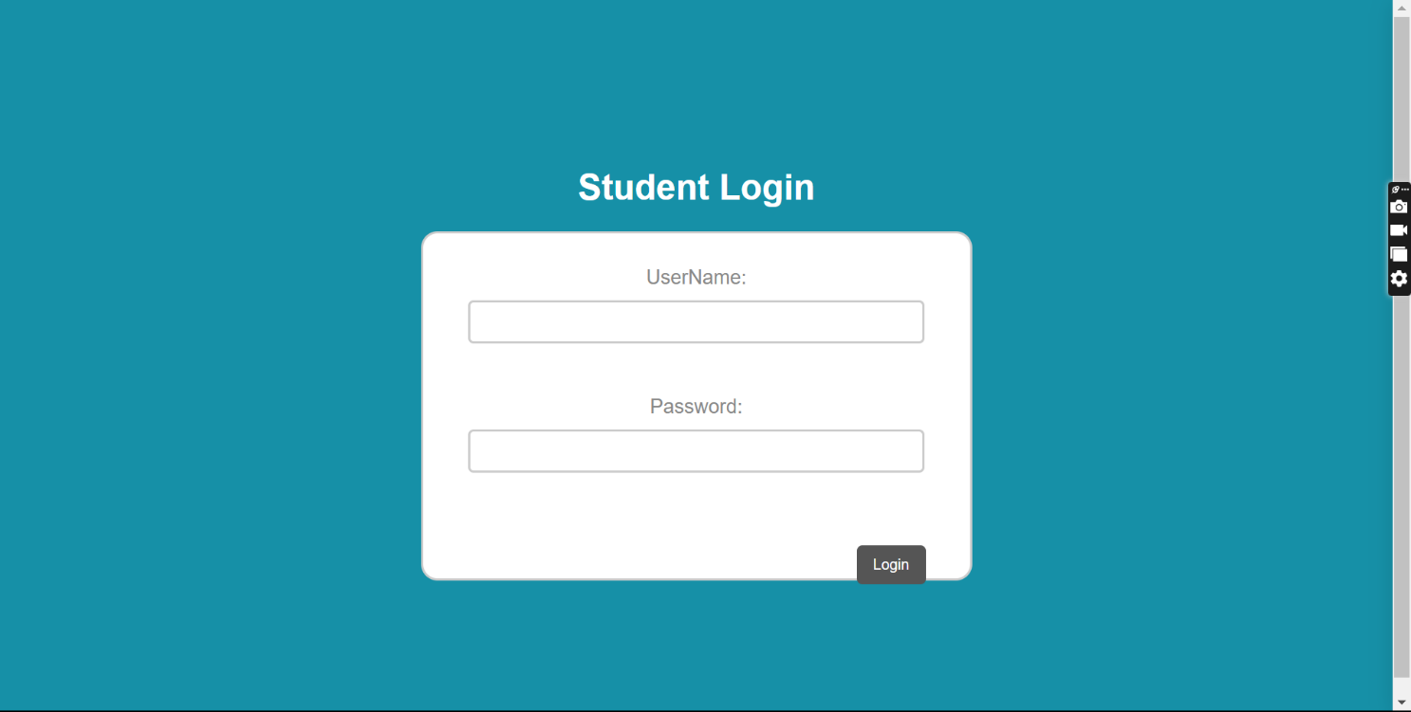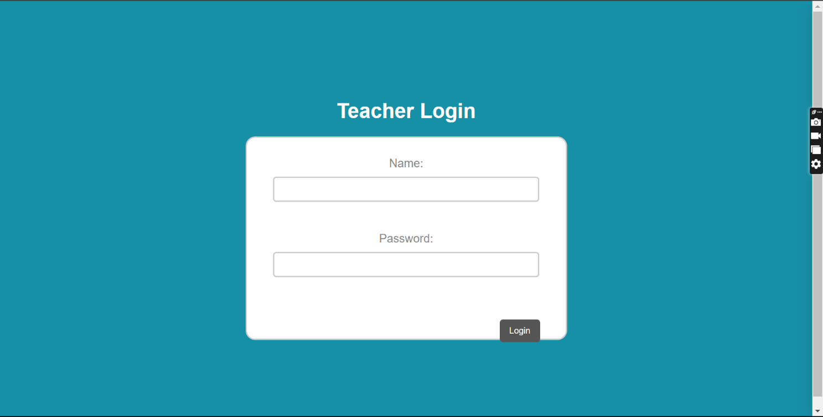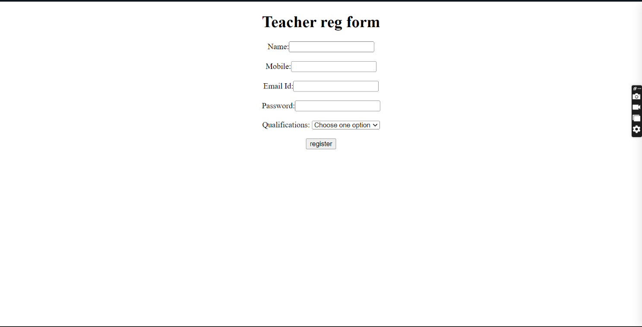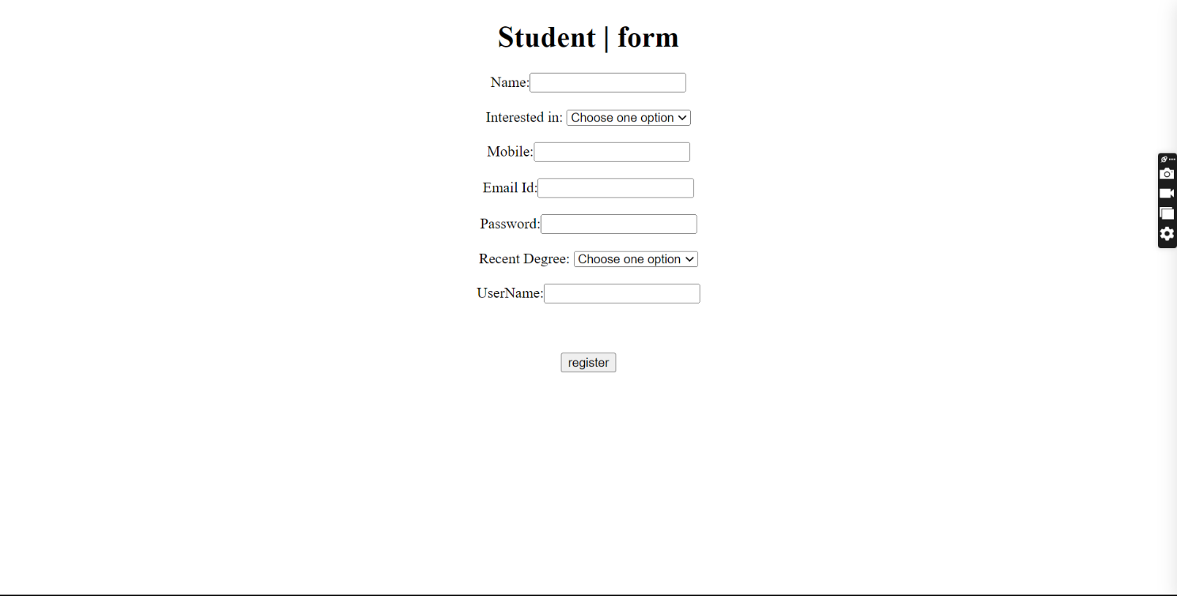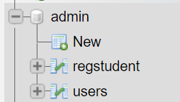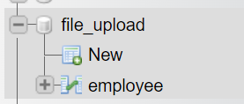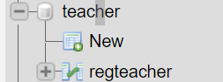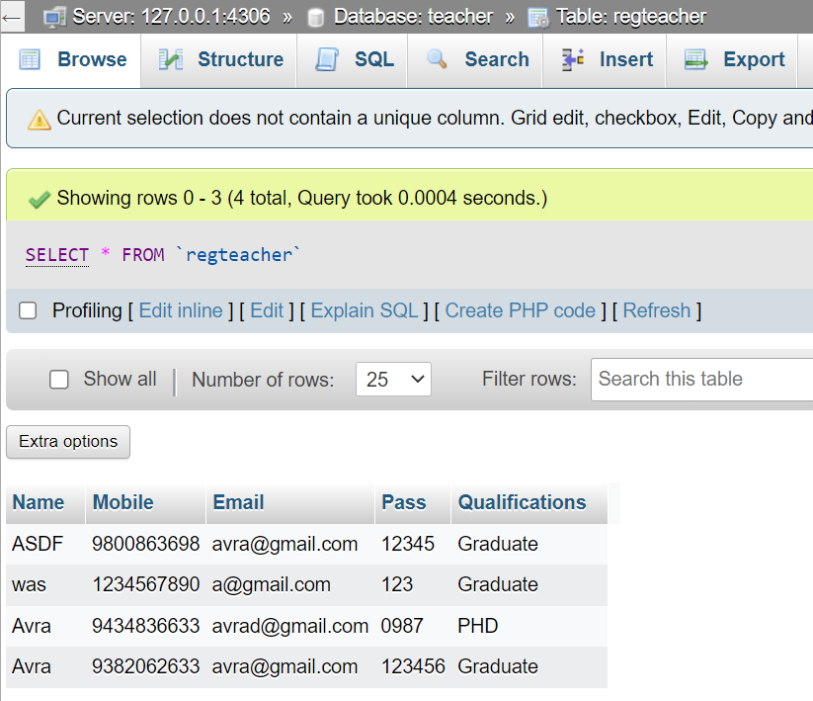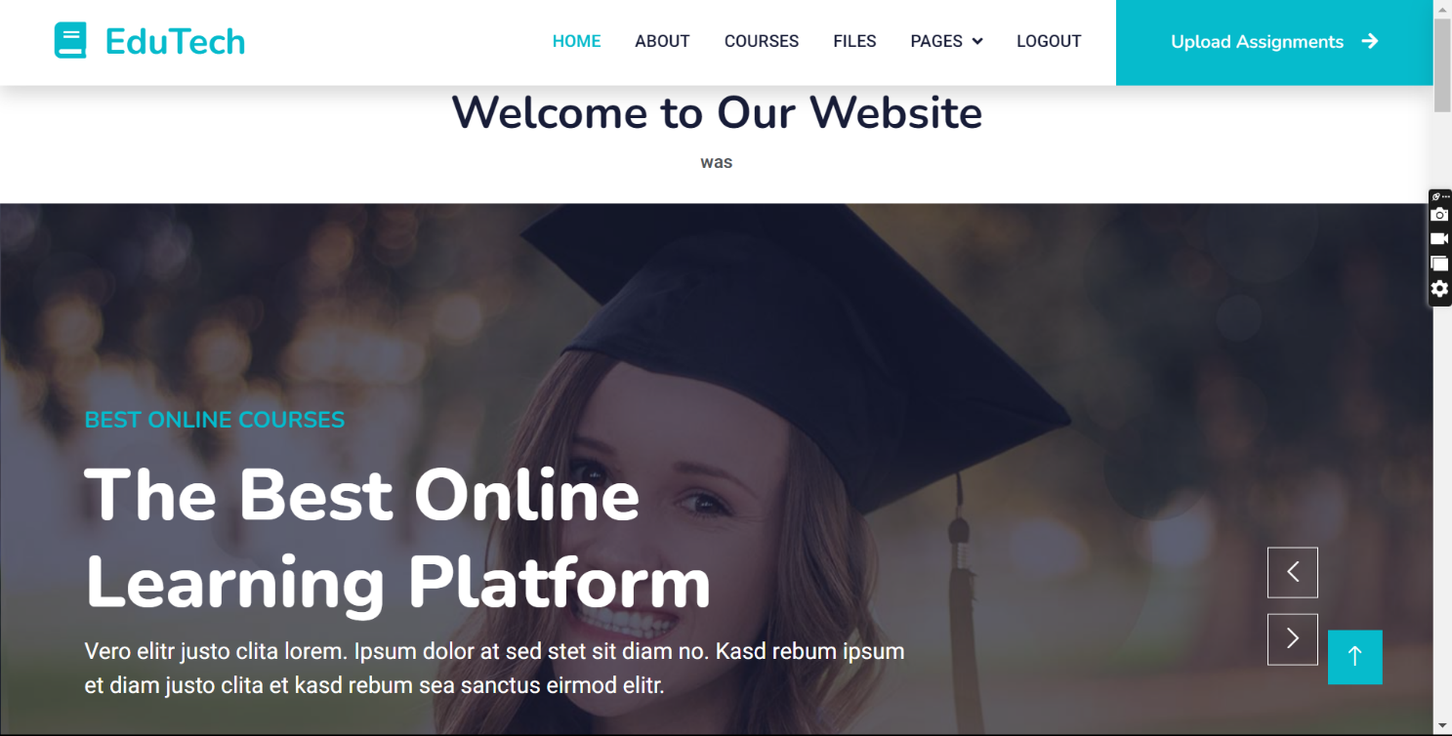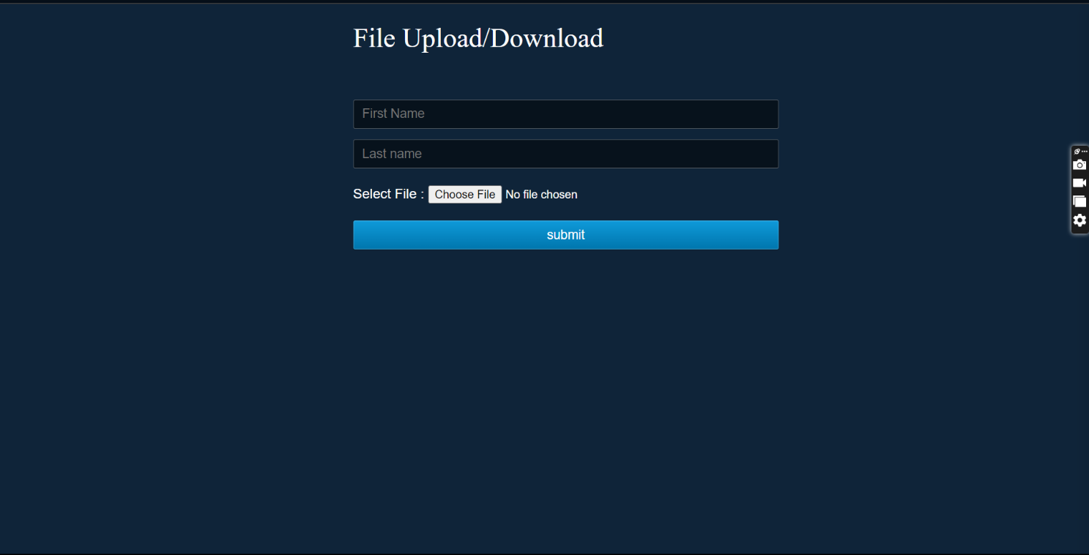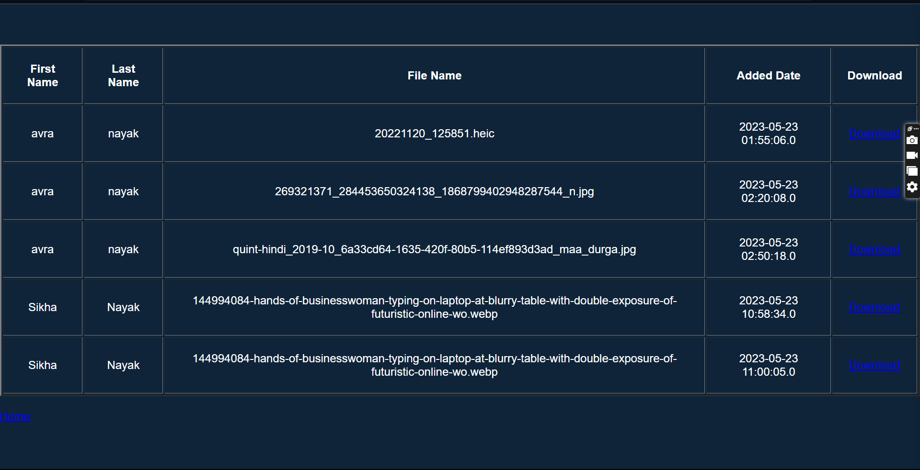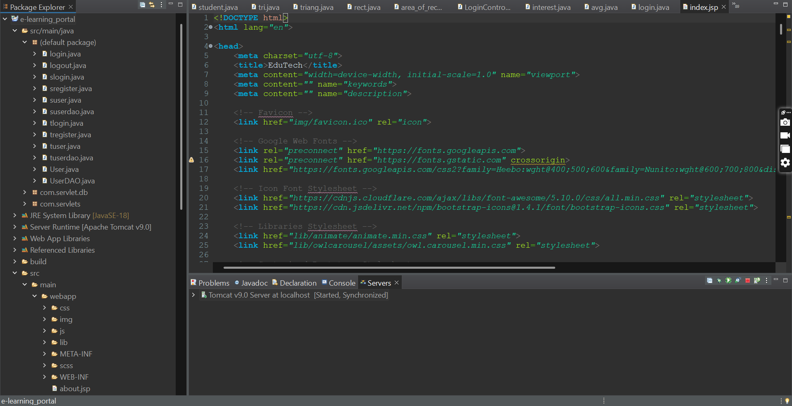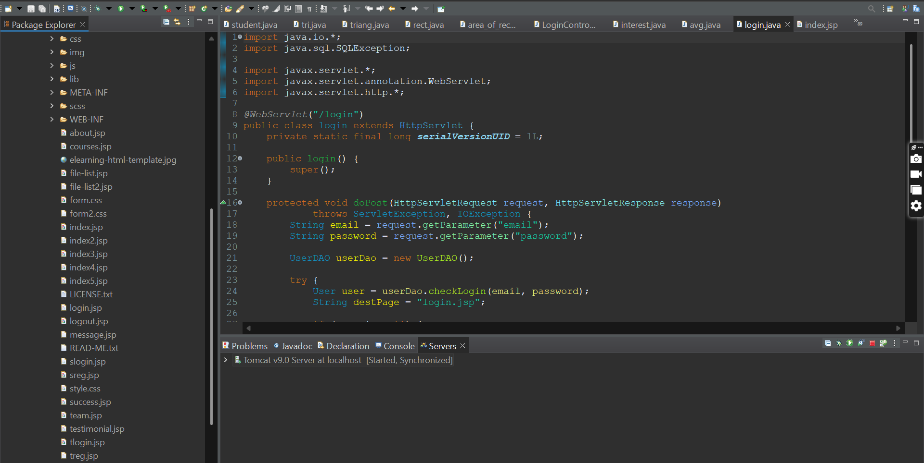

**CONCLUSION**

This project is made using java fullstack platform of servlet. Used apache, tomcat and mysql also for the database purpose.

And lastly we conclude that this project will help many students in their studies.

**BIBLIOGRAPHY**

* [www.wikipedia.com](http://www.wikipedia.com)
* Used of eclipse for implementing
* Used bootstrap for design

**THANK YOU**